SOP – SOC EI Validations

Name of Procedure – EI general validation by SOC
Date – 23/4/2024.
Created by - Puneet Tripathi
Introduction- EI validation consists of 3 primary aspects – Grafana, Stathub and ENI app stats.

- Mentioned below is a step-by-step process for validations with screenshots:

- Grafana

- Open the confluence link and move to RHEL9 server group (the CRQ environment decides for PROD/CTE / QA).

Link: https://confluence.csgicorp.com/x/58ooMw
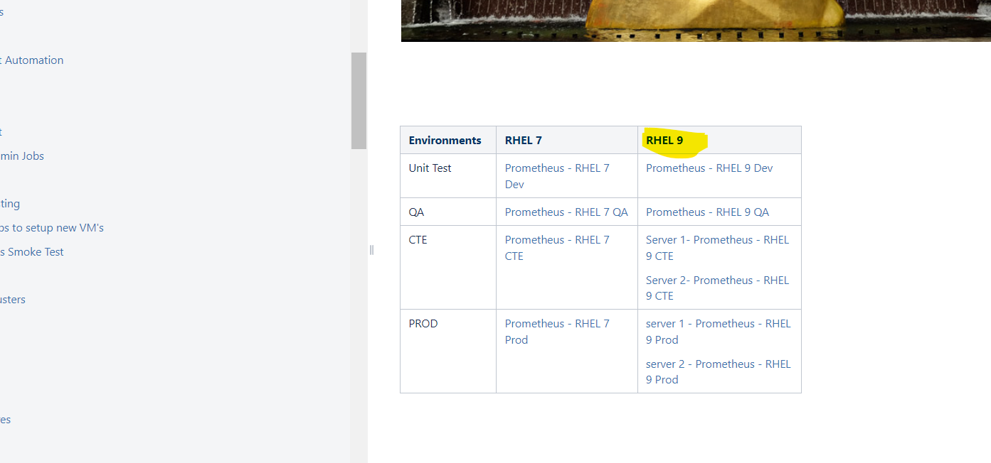

- Now we need to select “ENI Poller- port details” Dashboard :
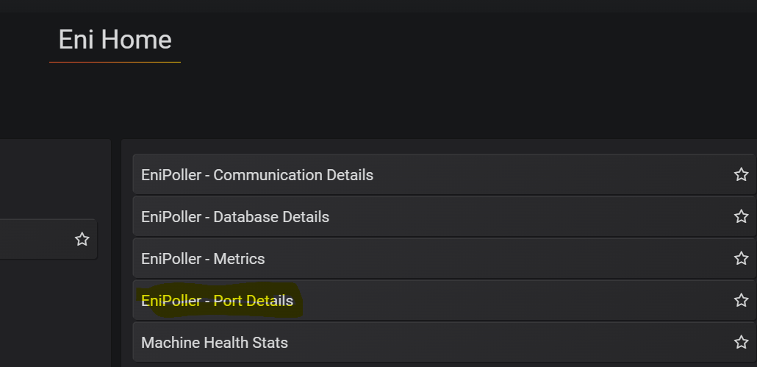

- One can also search for ‘ENI – Filter- Port details’ dashboard if it’s not pre-filled in the list :
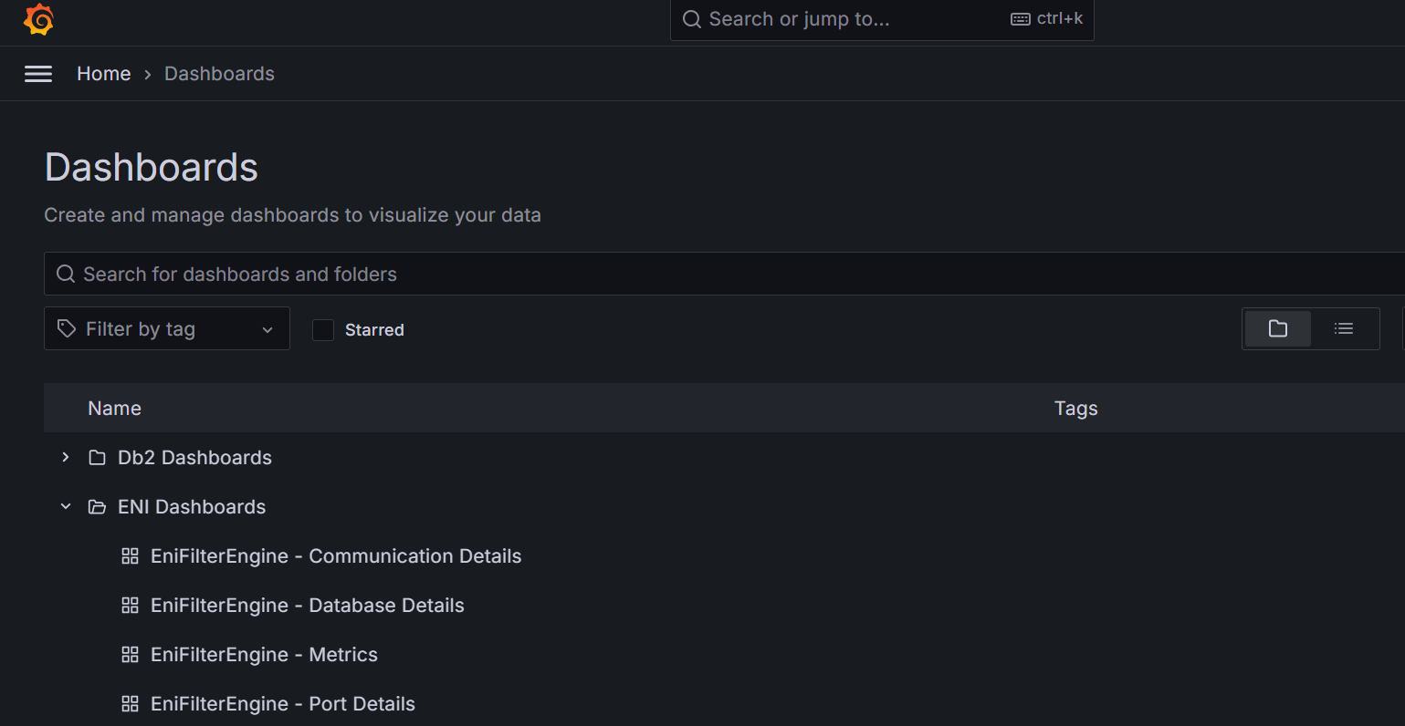

- Our primary goal is to look for ENI- filter and ENI-poller dashboards one by one . We need to access the ‘Rate of messages backlogged in a cycle’ visualization :
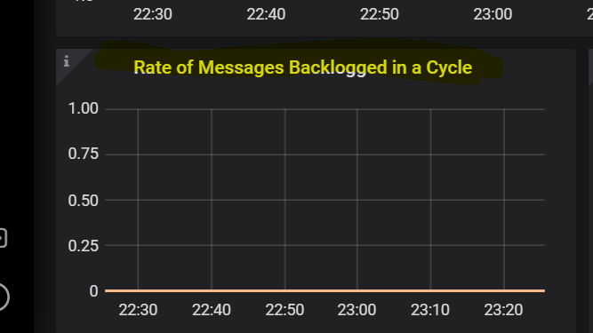

Analysis Mechanism - The logic here is that considering a buffer time of 5 minutes after the CRQ official timings there should not be any queueing/backlogged spikes in the graph. If we notice any spikes after the CRQ ends (considering the buffer time) we need to inform EI team (Via SRE-EI collab channel or to Manchikanti Venkata Satya Divya Teja / Prathap G from EI team)

- We need to filter the report for each cycle separately and analyse:
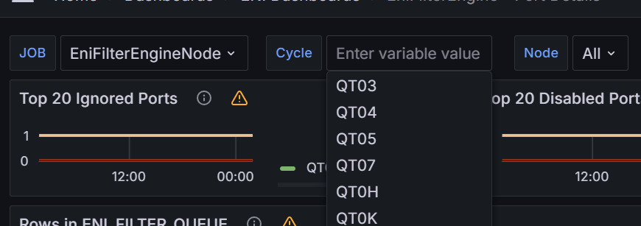

- ENI App stats :
Link : http://accdevxenia0045.sp.csgidev.com/#/poller/prod

Based on the CRQ environment we can identify whether a particular server is live or disabled hence we can filter out if backlogged messages are because of disabled servers thus such servers can be ignored.
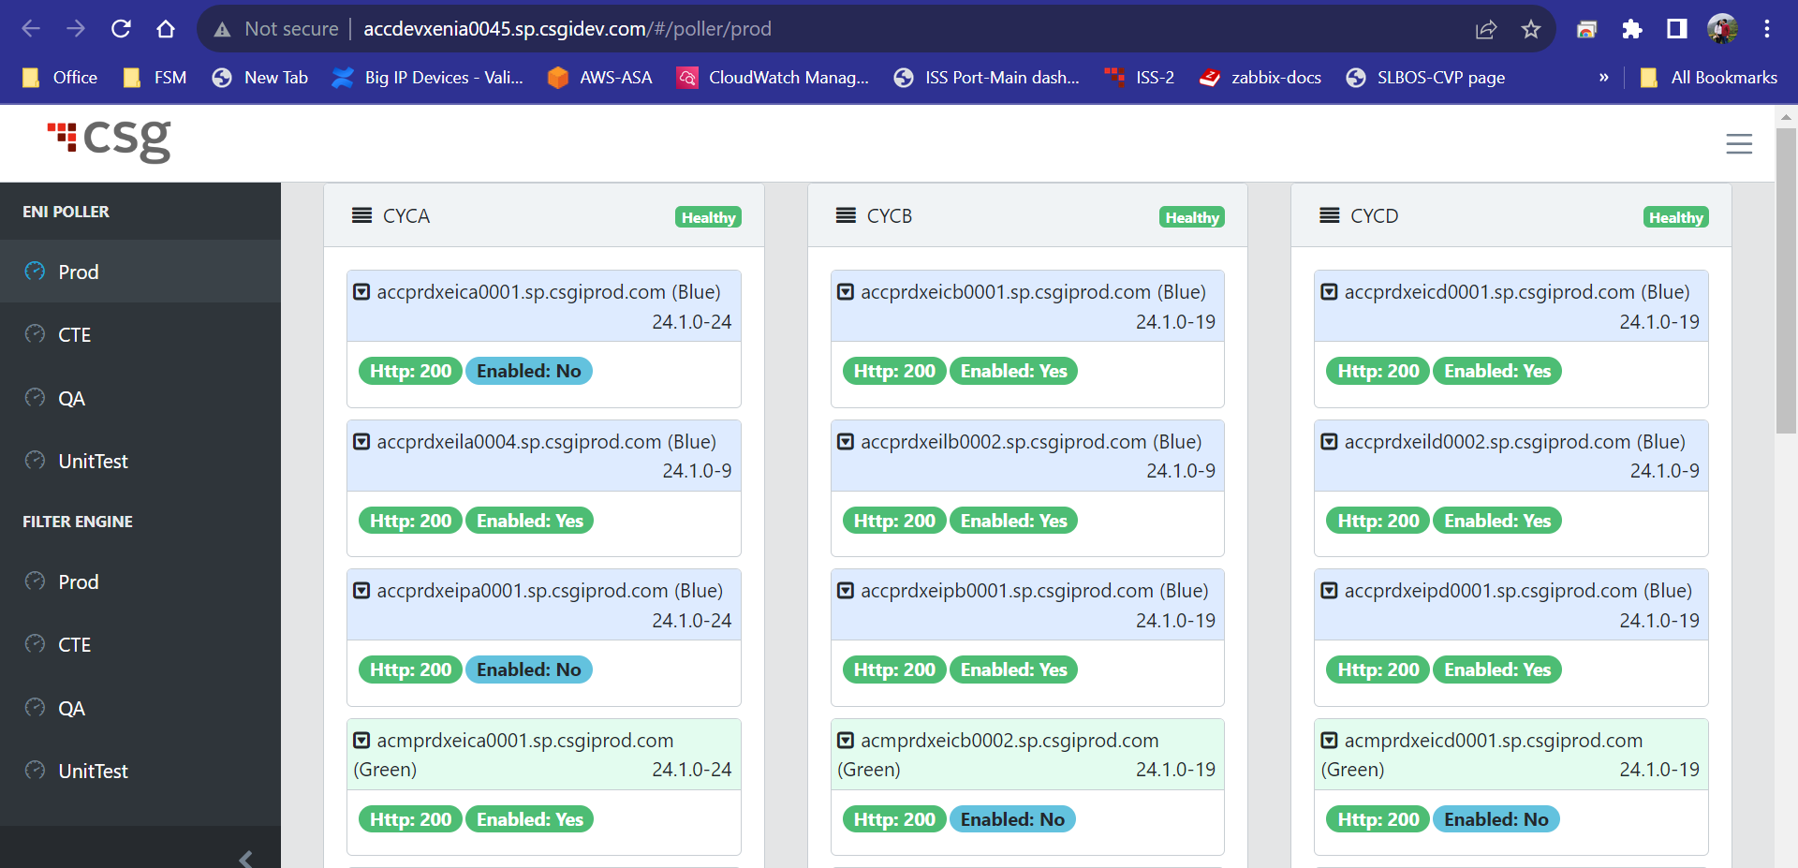

Basic server naming convention (Just FYI) :

EIC -Cap Server
EIP -Poller Server
EIL - Poller Parallel (Even)
EIF -Filter Server
EIL - Filter Parallel (Odd)

Eg – ACCPRDXEILA004 – EIL is even server and A- is the Cycle identifier (Cycle A/B/D) etc.

- Stathub

- We need to filter for ENIpoller and ENIfilter respectively in products and then look out for any spikes/errors that still occur after the CRQ timings (buffer time 5 minutes) .

Link : http://stathub.csgedirect.com/StatHubPortal_PROD/ActivityDetail/Ops#reportdate=today&productFamily=Enterprise%20Interfaces&product=EniPoller&timebucket=60&max_resp=2500

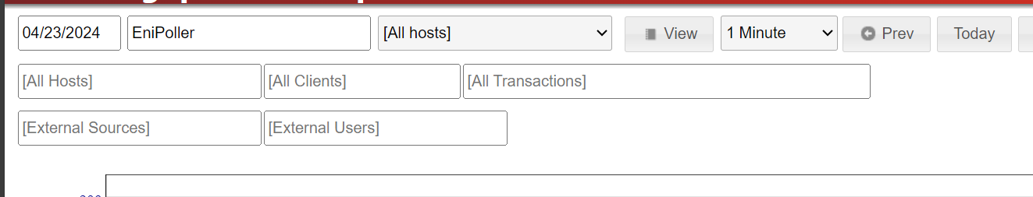

- We can check for new alerts after and during the CRQ timings considering buffer time :

Link : Trace Summary - StatHub Reports (csgedirect.com)

